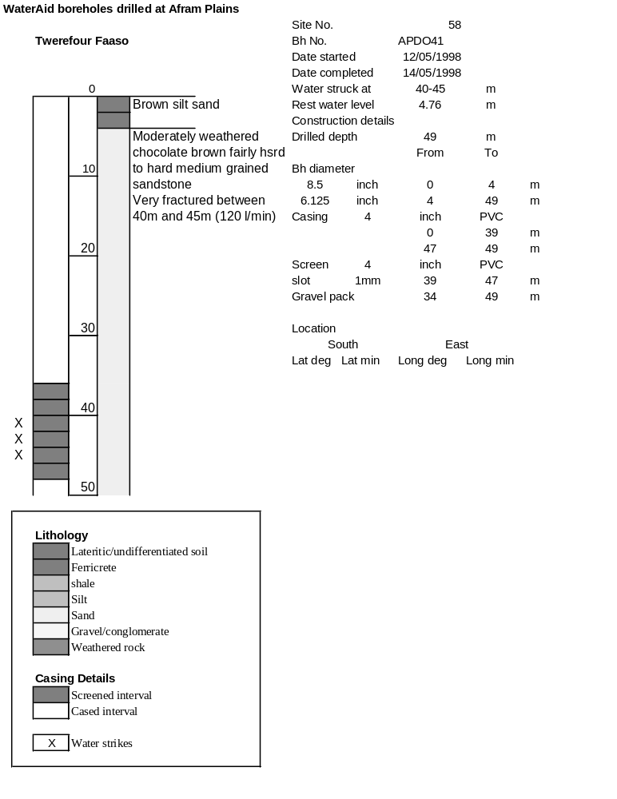

Borehole No. |  | APDO41
Hole No |  | 58 | (8)
Village |  | Twerefour-Faaso
Date |  | 23/11/1998
Point above GL |  |  | m
Pump depth |  | 38 | m
SWL |  | 4.76 | m
Start Time |  | 08:20
Drawdown test |  |  |  |  | Recovery Test
time | pwl (m) | Q l/min | dd | sc(q/s) | Time | wl (m) | t/t' | resdd
0.00 | 4.76 | 120.00 | 0.00 |  | 0.00 | 16.79
1.00 | 10.05 | 120.00 | 5.29 | 22.68 | 1.00 | 10.77 | 241.00 | 6.01
2.00 | 10.94 | 120.00 | 6.18 | 19.42 | 2.00 | 10.35 | 121.00 | 5.59
3.00 | 11.31 | 120.00 | 6.55 | 18.32 | 3.00 | 10.15 | 81.00 | 5.39
4.00 | 11.56 | 120.00 | 6.80 | 17.65 | 4.00 | 10.00 | 61.00 | 5.24
5.00 | 11.72 | 120.00 | 6.96 | 17.24 | 5.00 | 9.85 | 49.00 | 5.09
6.00 | 11.86 | 120.00 | 7.10 | 16.90 | 6.00 | 9.71 | 41.00 | 4.95
7.00 | 12.00 | 120.00 | 7.24 | 16.57 | 7.00 | 9.59 | 35.29 | 4.83
8.00 | 12.11 | 120.00 | 7.35 | 16.33 | 8.00 | 9.48 | 31.00 | 4.72
9.00 | 12.23 | 120.00 | 7.47 | 16.06 | 9.00 | 9.37 | 27.67 | 4.61
10.00 | 12.33 | 120.00 | 7.57 | 15.85 | 10.00 | 9.28 | 25.00 | 4.52
12.00 | 12.49 | 120.00 | 7.73 | 15.52 | 12.00 | 9.11 | 21.00 | 4.35
14.00 | 12.65 | 120.00 | 7.89 | 15.21 | 14.00 | 8.96 | 18.14 | 4.20
16.00 | 12.78 | 120.00 | 8.02 | 14.96 | 16.00 | 8.82 | 16.00 | 4.06
18.00 | 12.91 | 120.00 | 8.15 | 14.72 | 18.00 | 8.71 | 14.33 | 3.95
20.00 | 13.03 | 120.00 | 8.27 | 14.51 | 20.00 | 8.60 | 13.00 | 3.84
25.00 | 13.30 | 120.00 | 8.54 | 14.05 | 25.00 | 8.37 | 10.60 | 3.61
30.00 | 13.51 | 120.00 | 8.75 | 13.71 | 30.00 | 8.18 | 9.00 | 3.42
35.00 | 13.72 | 120.00 | 8.96 | 13.39 | 35.00 | 8.02 | 7.86 | 3.26
40.00 | 13.88 | 120.00 | 9.12 | 13.16 | 40.00 | 7.88 | 7.00 | 3.12
45.00 | 14.03 | 120.00 | 9.27 | 12.94 | 45.00 | 7.77 | 6.33 | 3.01
50.00 | 14.18 | 120.00 | 9.42 | 12.74 | 50.00 | 7.66 | 5.80 | 2.90
55.00 | 14.31 | 120.00 | 9.55 | 12.57 | 55.00 | 7.56 | 5.36 | 2.80
60.00 | 14.44 | 120.00 | 9.68 | 12.40 | 60.00 | 7.48 | 5.00 | 2.72
70.00 | 14.66 | 120.00 | 9.90 | 12.12 | 70.00 | 7.34 | 4.43 | 2.58
80.00 | 14.86 | 120.00 | 10.10 | 11.88 | 80.00 | 7.21 | 4.00 | 2.45
90.00 | 15.03 | 120.00 | 10.27 | 11.68 | 90.00 | 7.10 | 3.67 | 2.34
100.00 | 15.21 | 120.00 | 10.45 | 11.48 | 100.00 | 7.01 | 3.40 | 2.25
110.00 | 15.36 | 120.00 | 10.60 | 11.32 | 110.00 | 6.93 | 3.18 | 2.17
120.00 | 15.52 | 120.00 | 10.76 | 11.15 | 120.00 | 6.87 | 3.00 | 2.11
130.00 | 15.65 | 120.00 | 10.89 | 11.02
140.00 | 15.79 | 120.00 | 11.03 | 10.88
150.00 | 15.92 | 120.00 | 11.16 | 10.75
160.00 | 16.04 | 120.00 | 11.28 | 10.64
170.00 | 16.15 | 120.00 | 11.39 | 10.54
180.00 | 16.25 | 120.00 | 11.49 | 10.44
190.00 | 16.35 | 120.00 | 11.59 | 10.35
200.00 | 16.46 | 120.00 | 11.70 | 10.26
210.00 | 16.55 | 120.00 | 11.79 | 10.18
220.00 | 16.63 | 120.00 | 11.87 | 10.11
230.00 | 16.72 | 120.00 | 11.96 | 10.03
240.00 | 16.79 | 120.00 | 12.03 | 9.98

